The files for upload into the TSDS system are housed in third Party Extracts of the Student and Finance modules respectively.

File Creation

Finance > Reports > Third Party Finance Extracts

To create your staff file:
- Select the TSDS Unique Identifier Staff Extract
- Select the Mode:
  - Batch = runs for all staff with a position history for the selected school year, regardless of employment status
  - Missing = runs for all staff with a position history for the selected school year without a UID
- Select the Instructional Period – this will default to the active school year
- Select the Campus – to run for all, use the option ending with 000
- Set the Effective Date when that is the Mode selected
- Click
- The file will open as a Notepad document – Save this to your computer where it can be easily found. The system will name the file properly for you.

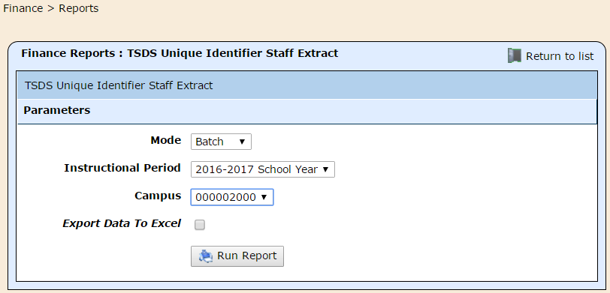

TSDS Upload/Download

Log into the Texas Student Data System (TSDS) portal through your TEAL login.

Important – TEAL/TSDS only works in Internet Explorer. Do NOT attempt to log in more than twice. This will lock you out of your account.

On the TSDS landing page, ensure you are in the correct district (for users with multi-district access)

Click on Manage Unique IDs

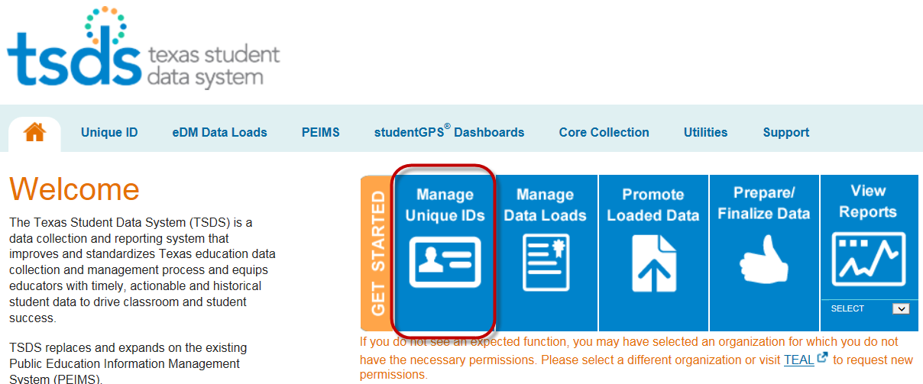

Click on the Unique ID menu bar

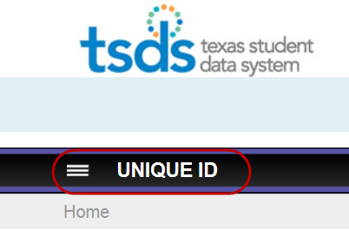

Choose Upload File

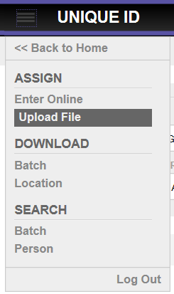

Click Browse and find the file on your machine.

Click Upload.

The screen will go to the Status bar – Click

You should now see the Uploaded Files list. Click Assign Unique ID to move on.

The screen goes back to the Status bar – click again.

You will now have the option to Resolve Near Matches and/or Assign Unique IDs.

Choose one of the employees in the list. TSDS will highlight the differences in the Master Record and the Submission Record.

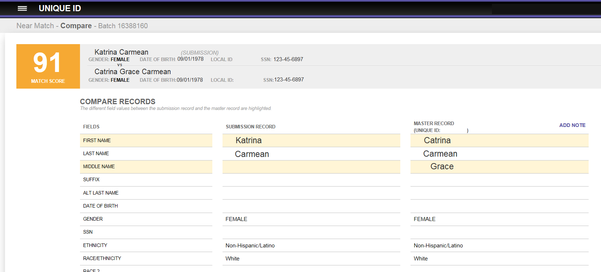

Double-check your HR packet (Driver’s License, Social Security Card, Passport…) to verify whether the Submission Record or the Master Record is correct.

If the Master Record is correct, update WebSmart to match the information in the Master Record.

If the Submission Record (the information you pulled from WebSmart) is correct, you will need to Update Master.

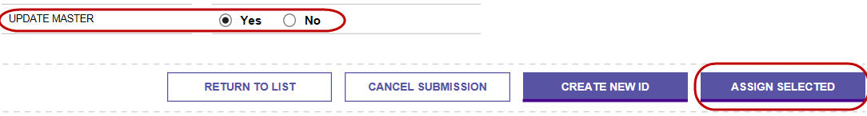

**Do not ever choose “Create New ID” – this can cause all sorts of problems when PEIMS rolls around and an employee has more than one UID**

Once you’ve worked through all of your Near Matches, you will be taken to the following screen:

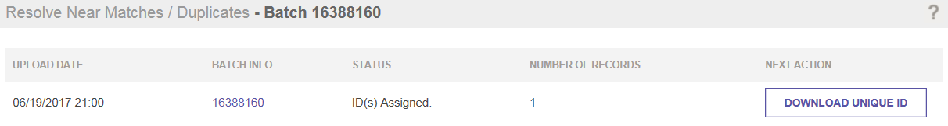
- Click on Download Unique ID. This triggers TSDS to create your extract file.
- Then, click on Download. This will open a new Notepad document.
- Completely delete the Header and Footer row of the document – if this step is not completed, the Import function will not execute.
- Save the Notepad document to your machine.

File Import

Admin > Admin > Data Management > Import/Export

In the Admin module, go to Admin > Data Management > Import/Export

Choose the Staff Unique Identifier Import

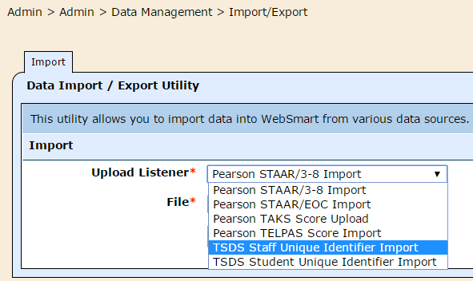

Click Choose File and find the file you downloaded from TSDS on your machine.

Click Import Data.

If the import was successful, you will see a summary screen showing how many records were imported.

Your HR files will be updated with the UIDs according to the schedule set in your database (Generally every 5 to 15 minutes).

