
Promote Contracts & Positions

Items needed to complete process:
- Employee Wage Report
- Contract Types & Working Days per Month for each Contract Type
- Contract Begin and End Dates for Each Type
- Pay Periods and Pay Dates
- Open Next Year Instructional Period
- Leave Policy
- Position Types

1. Prepare to Promote:
- Verify Current Leave Balances – Correct if necessary
- Update Leave Policies if Applicable-This MUST be done before promoting
- Terminate non-returning employees
- Update Pay Scales if Applicable
  - Finance > Payroll > Pay Schedules > Compensation Types
- Open Next Year Instructional Period
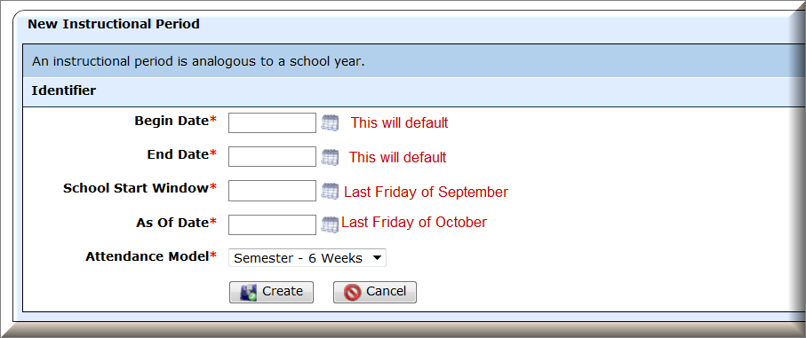
  - Admin > District > Instr. Periods

- Employee Wages Report
  - Report Scope = By Effective Date
  - Effective Date = current date
  - Run to Excel
  - Identify Terminated Employees and update position to “Do Not Promote.”
  - Identify positions that should not promote to new year and update on staff position
Go to Finance > HR > Staff Manager
    - Locate employee and click on edit icon
    - Select the Payroll Tab
    - Select Employment Contracts
    - View Positions
    - Edit Position to be updated
    - At top of Scheduled Payment Section select “Do not promote this position”

- Promote Contract Types
THIS PROCESS ROLLS LEAVE BALANCES FORWARD. IF CHANGING LEAVE POLICY IT MUST BE UPDATED BEFORE YOU COMPLETE THIS PROCESS.

Go to Finance > HR > Organization > Promote Contracts
- Select the Contract Types Tab
- Select the intended Target Period
- Check the box next to each Contract Type to Promote
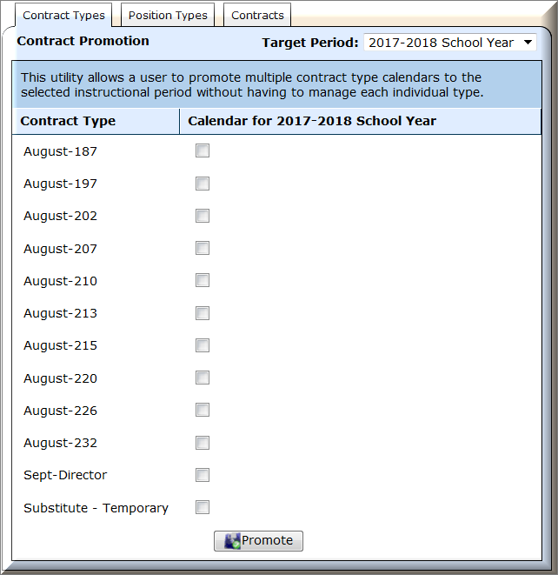
- Select Promote

- Promote Position Types
This utility allows a user to promote multiple position types to the selected instructional period without having to manage individual position types.

a. Select the Position Types Tab
b. Select the intended Target Period
c. Select Contract Type for each Position Type for Target Period Year
- Default will duplicate previous year
- Select different Contract Type for a Position Type
- Select None if you will not be using a Position Type in the upcoming year.
d.Select Promote

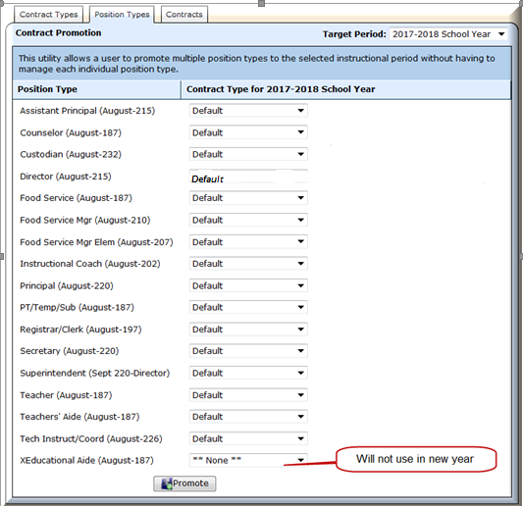

- Promote Contracts

- Select the Contracts Tab
- Select Target Period
- Contract Type/Position Type –Categories are by Contract Type. Position Type is listed under the Contract Type it is attached to.
- Contract Begin – Enter the Begin dates for each Contract/Position Type
- Contract End – Enter the End dates for each Contract/Position Type. Be sure to watch the dates carefully.
- Salary, Hourly, and Daily Increase – If selecting an option other than 0% a salary increase will automatically calculate and be applied to all staff members on that Postion Type during the promote process.

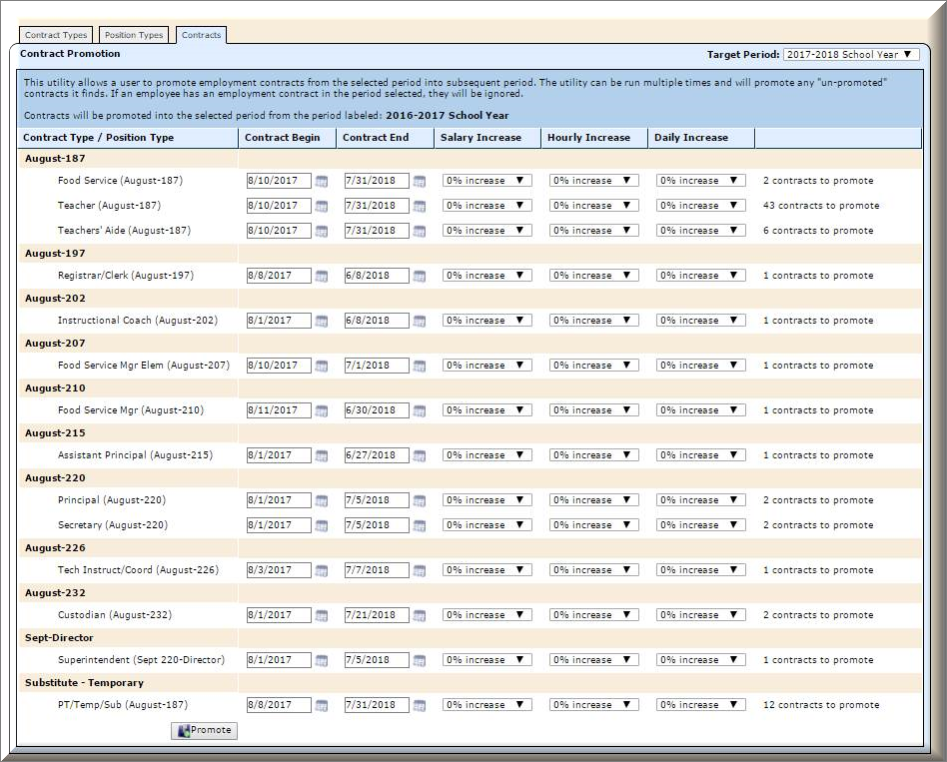

After Promotion Processes

- Verify Contract Types:
The days entered on the Contract Type calendar are used in the current TRAQS and the upcoming TEAMS reporting process. It is important that this data is correct for each employee.

Go to Finance > HR > Organization > Contract Types
  - Verify Payroll Begin Dates and number of Days on Contract Types
  - Update Days per Month if Necessary

- Add New Contract Types
  - Select Add Contract Type
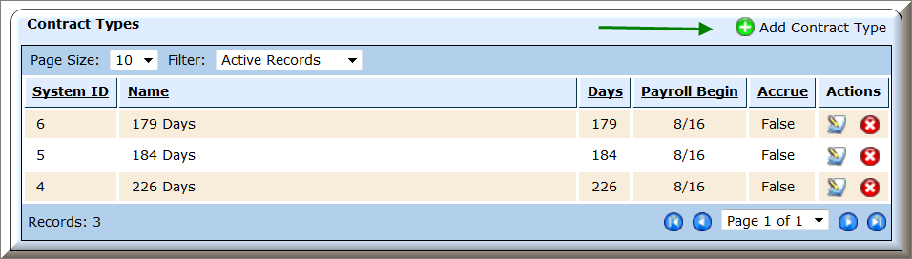
  - Complete the Identifier fields – Note: Payroll Begin date should be the first day of the first pay period for the new instructional period.
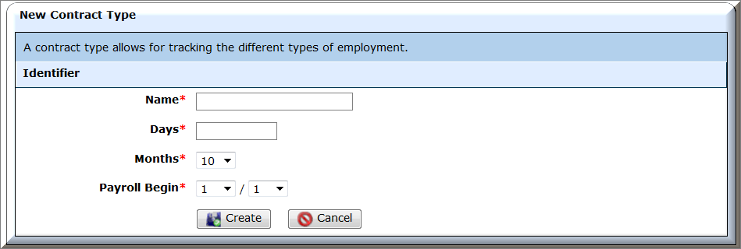
  - Select Create
  - Select the Calendar tab
  - Edit the Instructional Period Calendar

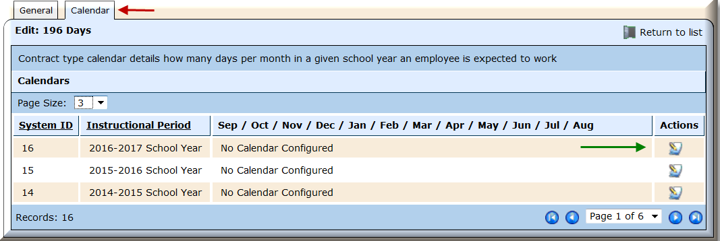

  - Enter the number of days worked for each month
(Note: August is listed at the bottom, if contract days start in August you must enter the number of days in that section.)

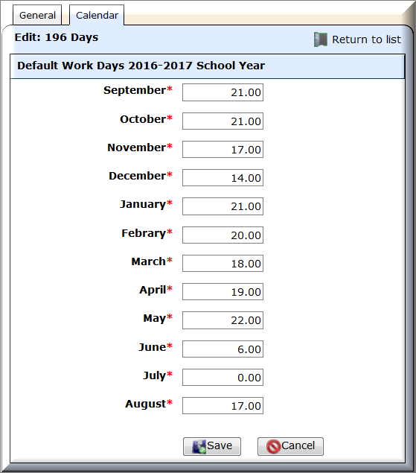

Be sure the total number of days worked equal the Contract Days.
If the days do not match, the user will receive an error.

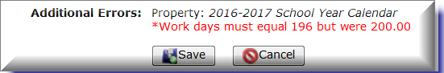

  - Select Save
  - Select Return to List and repeat for each Contract Type
  - Identify the Contract Types that need to be deleted – Do NOT delete yet

- Verify Position Types
Position Types manage default hours per Contract Type for TRS reporting. . The hours entered on the Position Type is used in the current TRAQS and the upcoming TEAMS reporting process in WebSmart. It is important that this data is correct for each employee.

Go to Finance > HR > Organization > Position Types
- Identify Position Types that need to be deleted – Do NOT delete yet
- Verify number of hours on Position Types that were promoted and update if necessary.

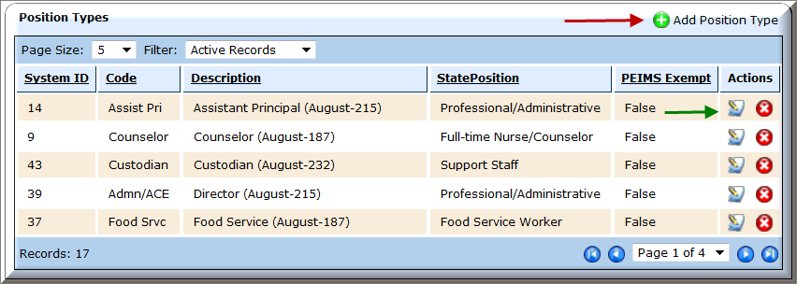
  - Select Edit
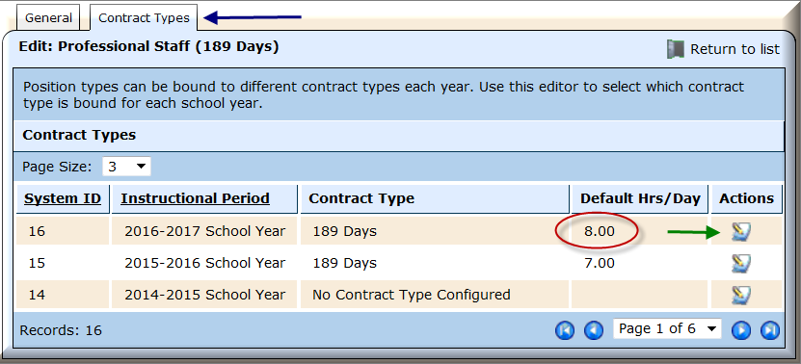
  - Select Contract Types Tab to view the number of daily hours on the position

  - Edit if necessary

- Verify Promoted Staff Contracts
Run the Employee Wage report
- Report Scope = By Instructional Period
- Instructional Period = 2017-2018 School Year
- Run to Excel
- Verify promoted data and identify changes to be made and make the changes. See how to Instructions below.
- A teacher may need to be moved to an administrator
- You may have one counselor that works a different number of days
- Registrars and changing from 190 days to 206
- All Instructional coaches are moving to Teachers Aide
- Run the Employee Wages report again to verify all changes have been made.
- Run the Employee Leave Report and verify Leave promoted based on policy for new instructional period
- Delete any unused Contract Types and Position Types

Update Individual Employee Calendars

- Go to Finance > HR > Staff Manager
- Edit the employee
- Click on the Payroll tab
- Click on the Position
- To override the calendar from the Contract Types, select Calendar icon under Actions
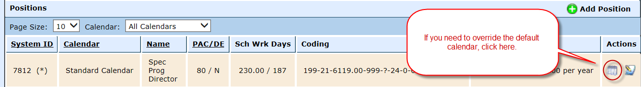
- To customize the employee’s calendar, select “TRUE – Provide Custom Calendar”

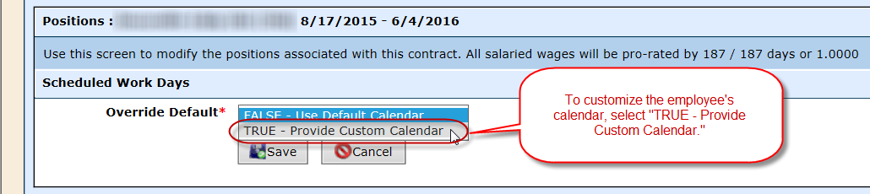
- Now the user can adjust the Scheduled Hrs/Day and/or the Calendar Days per Month for an individual employee only. The updated days will be reported to TRS.
- Select Save.
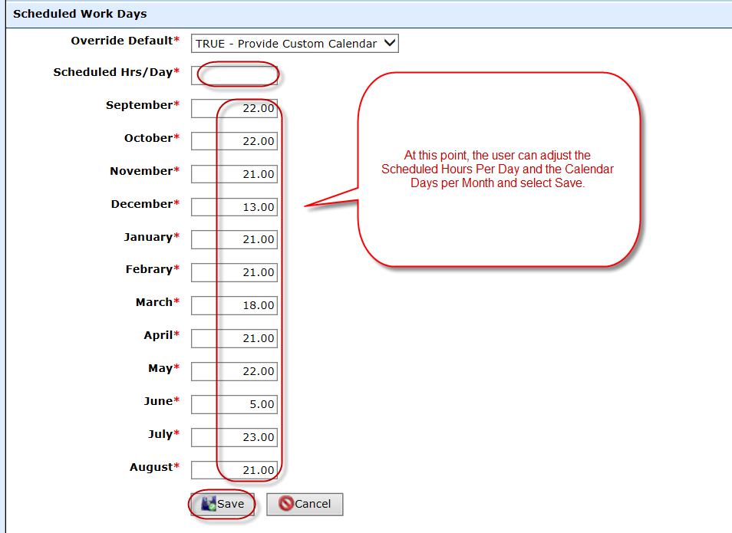

Update the number of days per week the employee works

- Go to Finance > HR > Staff Manager
- Edit the employee
- Click on the Payroll tab
- Click on the Position
- The number of days per week the employee works defaults to 5 days per week. If the user needs to edit the number of days for an individual employee, select the Edit icon under Actions
