Opening a New Instructional Period

Instructional Periods are the container for the entire year. This affects both the Finance and Student portions of the software. These are typically July 1 - June 30 or August 1 - July 31

Admin > District > Instructional Period

To Add an Instructional Period
- Click Add Instructional Period
- Edit the Begin Date and End Date - typically July 1 - June 30 or August 1 - July 31
- Edit the School Start Window - the last Friday of September
- Edit the As Of Date - the last Friday of October
- Click Create
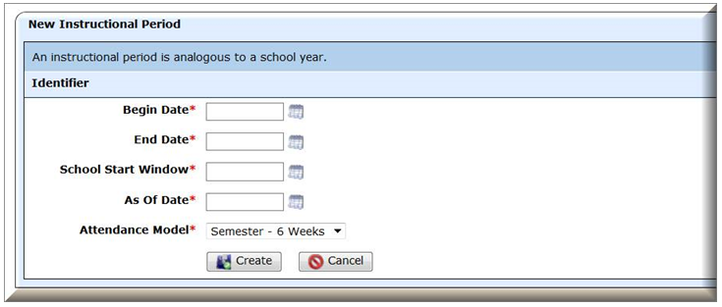

Queries:
When choosing the Instructional Periods Screen, the default view populates with the All Active Records Query; however, you can select any of the following queries.
- All Open Periods - Shows all open periods. An Open Period can be worked in and entries linked to an open period can be edited - i.e. Service Records, Course Enrollments history.
- Closed Periods - Shows all closed periods. A Closed Period cannot be worked in and entries linked to a closed period cannot be edited - i.e. Service Records, Course Enrollments history.
- Custom Query - This option allows the user to filter and search based on criteria the user defines.

To Manage the Instructional Period¶
- Click the to access the appropriate tabs.

Defining the "Active Year"¶
- Click the next to the year to be set as the "Active Year."

To Close an Instructional Period
Closing an Instructional Period "locks" the year, preventing any changes from being made. The current Instructional Period should never be locked. Generally, some previous years are left open to allow editing of data - i.e. leave information on Service Records and Course Enrollment history for Transcripts. If a Closed Period needs to be worked in, it can be re-opened.
- Click the for the Instructional Period to close it

To Open a Closed Instructional Period
- Select the Closed Periods Query
- Click on the Instructional Period
- The Instructional Period can now be worked in and is visible in the All Open Period Query
- Use caution when opening closed Instructional Periods and making changes.

Actions
= Add
= Edit
= Management - Leave Accrual, Pre-Enrollment, Enrollment
= Active Year
= Inactive Year, click to make Active
= Close
= Restore/Re-Open

